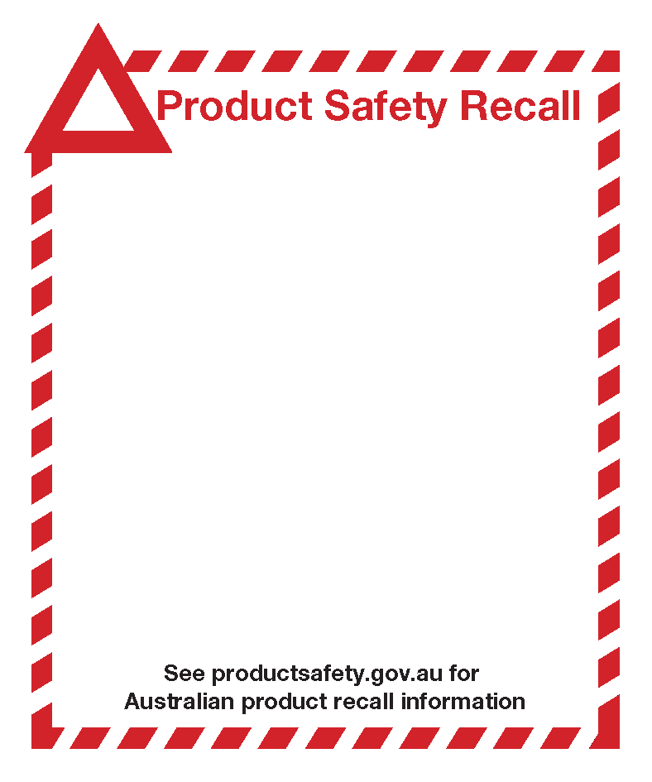

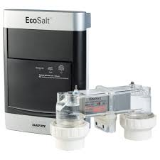
EcoSalt™ Salt Water Chlorinators
Davey Water Products Pty Ltd is issuing a product recall on its range of EcoSalt™ Salt Water Chlorinators sold in Australia through various retailers and pool builders.
Which models are affected?
All EcoSalt™ Chlorinators are affected. These products are used as a pool sanitation system in small to medium-sized domestic pools and large swim spas. They have been manufactured by Davey for approximately 10 years and distributed throughout Australia.
How do you identify the product?
The EcoSalt™ Chlorinator can be easily identified. The chlorinator cell is connected to the power supply and the power supply contains a label which identifies the product as an EcoSalt™ chlorinator.
Product issue
There have been reports of some cell components of the EcoSalt chlorinators fracturing/rupturing, causing damage to the cell and occasionally to connecting pipework.
Hazard
If the cell was to fracture or rupture, plastic fragments could be ejected and cause injury to bystanders. No injuries have been reported at the time of this notice.
What should I do?
Davey recommends that consumers with an EcoSalt™ chlorinator should immediately:
- read the supplementary product information - "Important Safety Instructions for Use" - available at Davey's website (www.davey.com.au/flowswitch) and ensure that your pool pump circulates sufficient water to completely fill the chlorinator cell during the chlorination process; and
- contact Davey to arrange the free installation of a mechanical flow switch. Consumers can contact Davey's dedicated hotline on 1300 889 387 between 9am and 5pm on Monday to Friday AEDT, visit www.davey.com.au/flowswitch or contact your local Davey pool equipment dealer.

