

**FOOD RECALL**

**See www.foodstandards.gov.au/recalls**

**for Australian food recall information**

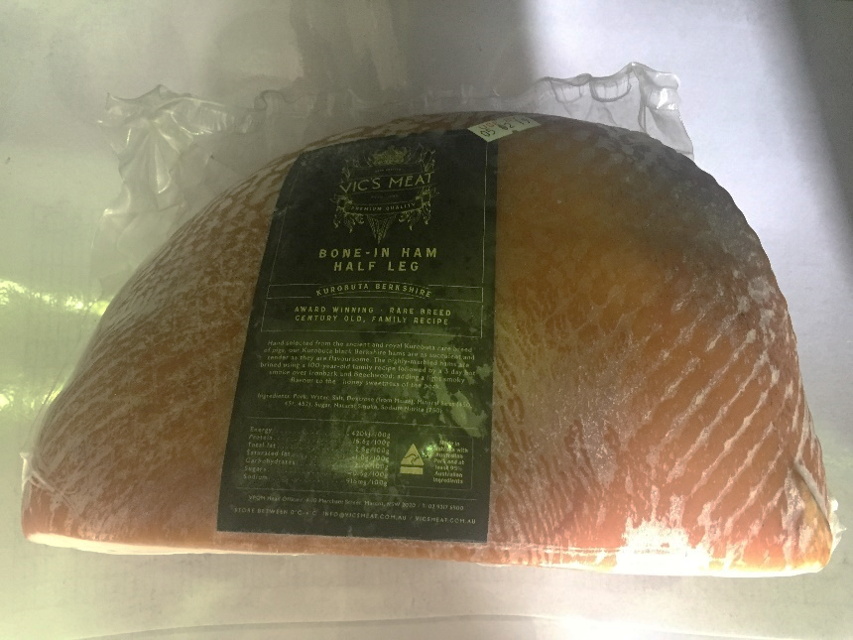

**Vic’s Meat BONE-IN HAM HALF LEG 4.5kg Best Before 29/01/2019**

Vic's Premium Quality Meat is conducting a recall of the above product. This product has been made available for sale at Victor Churchill NSW, Simon Johnson NSW, VIC and WA and Vic’s Meat Brisbane.

**Problem:** The recall is due to microbial (*Listeria monocytogenes)* contamination.

**Food safety hazard:** Listeria may cause illness in pregnant women and their unborn babies, the elderly and people with low immune systems.

**What to do:** Any consumers concerned about their health should seek medical advice and should return the product to the place of purchase for a full refund. For further information please contact:

**Vic's Premium Quality Meat**

**(02) 9317 6900 www.vicsmeat.com.au**

**See www.foodstandards.gov.au/recalls**

**for Australian food recall information**