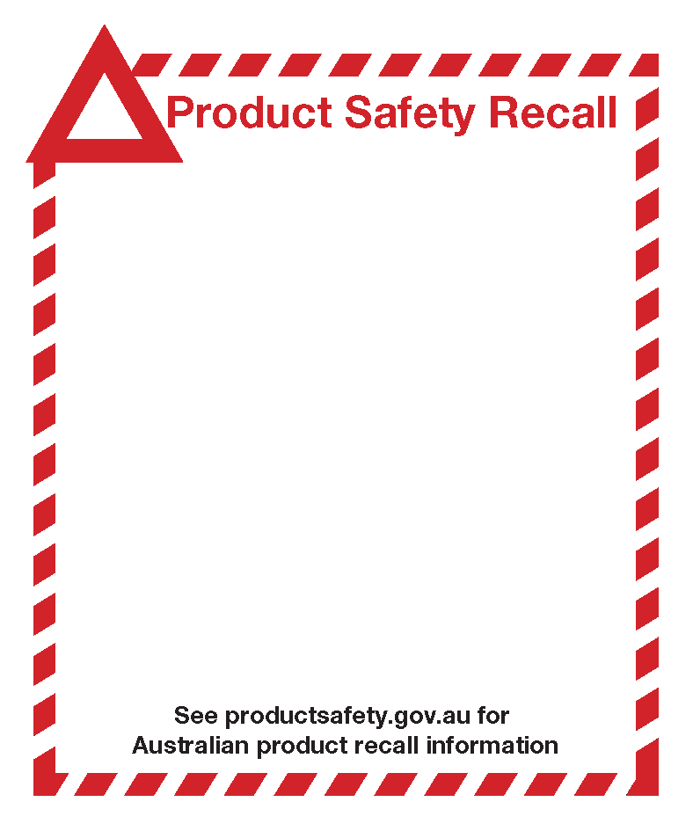

Sold between January 11, 2017 to June 30, 2017. This machine can be identified by the name Aeroglide Rapid Iron model number SR6370, type 1128 2000 – 2400W and date of manufacture 5216.

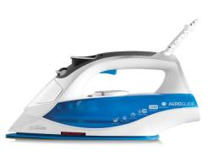

**Defect:** The product has only a single layer of insulation between the wiring and the top of the iron, which is not compliant with Australia safety standard 60335.2.3.

**Hazard:** The product is not in compliance with Australia safety standard 60335.2.3 and there is a possible risk of electric shock.

**What to do:** Stop using the machine, return the product to Sunbeam for a full refund or higher value replacement product.

**Contact details:** Please reach out to the Sunbeam Corporation Pty Ltd.consumer services team at 1300 881 861 (Monday-Thursday 8:30 am – 5 pm AEST, Friday 9:30 am – 5 pm AEST) to learn if your product is affected.

**Sunbeam Aeroglide Rapid Iron model SR6370**

**Date of manufacture 5216 only**