7-9 Arco Lane, Heatherton, Victoria 3202
Name Surname
Address 1
Adresss 2
SUBURB STATE PC

IMPORTANT SAFETY NOTICE

Dear <insert Name Surname>,

BSH Home Appliances Pty Ltd (BSH), the distributor of Bosch home appliances in Australia, has identified an issue affecting some dishwashers in 20 models of Bosch branded dishwashers manufactured between 2000 and 2006. Our records indicate that you may own one of the affected dishwashers.

The purpose of this letter is to inform you that, in response to this product issue, BSH is undertaking a Product Safety Repair Action. Please find attached a copy of the recall advertisement.

Why is BSH taking this action?

BSH believes that some Bosch branded dishwashers in the affected models (see below) may potentially develop cracks in the printed circuit board within the control module. Depending upon individual operating circumstances, these cracks could potentially lead to melting of soldering material or, in an unlikely event, ignition of a fire in the dishwasher. To date, no injuries have been reported.

Which models are affected?

Dishwashers in the following 20 models of Bosch dishwashers may be affected: SGI4335AU; SGI4345AU; SGI4347AU; SGI43A25AU; SGI43A45AU; SGI43A55AU; SGI4705AU; SGI4715AU; SGI53A55AU; SGS4332AU; SGS4352AU; SGS43A92AU; SGS43B22AU; SGS43B42AU; SGS4702AU; SGS4712AU; SGS5332AU; SGS53A52AU; SRI43A05AU; and SRS5302AU.

The model number for your Bosch dishwasher can be found as shown in the diagram below.

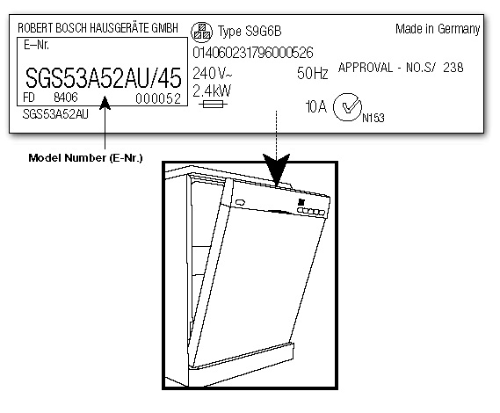

To verify that your dishwasher is affected, please visit our dedicated website at www.bosch-home.com.au/repair or contact our toll-free repair helpline on 1300 851 644 between 9am – 5pm AEDT Monday to Friday to schedule a repair.

When does this product issue occur?

BSH Australia believes that the product issue only occurs while the dishwasher is in use. More specifically, if the issue arises, it will only do so during the relatively short phase of the dishwasher's cycle when the water is being heated to its required temperature.

The product issue cannot occur when the dishwasher is not in use.

Should you continue to use your dishwashers if you own an affected model?

No. Cease using the dishwasher immediately and switch it off.

What does the Product Safety Repair Action involve?

To uphold BSH’s high standards of safety and quality, a simple, fast and free repair service has been set up. This involves an authorised and trained repair agent visiting your home to replace the dishwasher's control module. The replacement of the relevant component is a simple procedure which should only take approximately 45-minutes and will usually be carried out within 7 business days of booking.

What do you need to do?

The action you will need to take depends on which of the following categories apply to you.

What is your situation? | Action required
You still own an affected dishwasher and have not taken any action in relation to this product issue and would like to have your dishwasher repaired | You can either:  - visit the dedicated repair website located at www.bosch-home.com.au/repair; or  - call the Bosch Repair Team on 1300 851 644 to organise an authorised and trained repair agent to visit your home to replace the dishwasher's control module.
You still own an affected dishwasher and have not taken any action in relation to this product issue and have decided not to have your dishwasher repaired | You must do either of the following:  - put a tick in the box to the right and return this letter in the prepaid envelope enclosed;  OR  - visit www.bosch-home.com.au/repair to register this information with us.
You still own an affected dishwasher but it is no longer being used | You must do either of the following:  - put a tick in the box to the right and return this letter in the prepaid envelope enclosed; OR  - visit www.bosch-home.com.au/repair to register this information with us.
You once owned, but have disposed of, one of the affected Bosch branded dishwashers | You must do either of the following:  - put a tick in the box to the right and return this letter in the prepaid envelope enclosed; OR  - visit www.bosch-home.com.au/repair to register this information with us.
You once owned one of the affected dishwashers but you have passed, or sold, your dishwasher to someone else (e.g. you have moved house) | You must do the following:  - provide the new owner of the dishwasher with this letter so that they can contact us via the hotline or the dedicated website; and  - if known, provide us with the name, address and phone number of the new owner.
You have already contacted us and had the repair undertaken | Please provide us with your feedback on the repair by visiting: www.bosch-home.com.au/repair

Your personal safety and continued satisfaction is of utmost importance to us. Furthermore, BSH takes pride in offering safe products of high quality and we sincerely apologise for any inconvenience that this product safety repair action may cause.

Please contact the Bosch Repair Team on our dedicated, toll-free helpline on 1300 851 644 between 9am – 5pm AEDT Monday to Friday if you need further information.

Yours faithfully

Daniel Bobik
Product Action Leader
National Marketing Manager
BSH Home Appliances Pty Ltd

Enclosures (2)

