ACCC analytical survey of formaldehyde in false eyelash glues supplied in Australia

Final report

August 2015

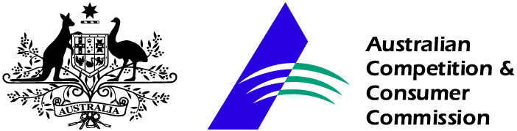

Contents
1. Background 3
2. Potential Hazards 3
2.1 Injury reports 4
3. Standards and Regulation 4
3.1 Australian regulation 4
3.2 International Regulations 5
4. Survey aim and rationale 5
4.1 Survey 5
4.2 Results 6
5. Conclusions 6
Attachment 1: Results table 7

This survey report describes the findings of an analytical survey commissioned by the ACCC. The report reflects only the findings for the specific samples obtained and tested as part of the survey. The results should not be taken to be indicative for all products of the same kind either before, during or after the survey period.
When a survey result suggests a product may be unsafe or non-compliant the ACCC will contact the supplier and work with them to investigate the issue and remove the product from the marketplace where adverse results are confirmed. Importantly, while adverse survey results may result in products being corrected quickly, there is also no assurance that favourable survey results mean that a product continues to be safe or compliant in the future.

1. Background

The Australian Competition and Consumer Commission (ACCC) has an important role in consumer product safety. The ACCC administers national product safety regulations under the Competition and Consumer Act 2010 and monitors the safety of general consumer products. This includes educating suppliers and consumers about regulations, emerging issues, and the safe use of products to minimise the risk of injuries.

In response to reports of injuries associated with cosmetics designed to be applied to the eyes, the ACCC conducted a research survey to identify the presence of formaldehyde in false eyelash glues.

The ACCC has undertaken testing of cosmetics for formaldehyde content in the past which has led to the recall of products that contain unsafe levels of formaldehyde.

2. Potential Hazards

Exposure to formaldehyde through the use of cosmetics is a recognised hazard and regulations to manage the risks arising from formaldehyde exposure exist in many countries, including Australia.

A NICNAS review found that formaldehyde is readily absorbed in humans and experimental animals by all exposure routes. When inhaled, it reacts rapidly at the site of contact and is quickly metabolised in the respiratory tissue. Following acute exposure via inhalation, dermal and oral routes, formaldehyde is moderately toxic in animals. The critical health effects of formaldehyde for risk characterisation are sensory irritation, skin sensitisation and carcinogenicity.

Humans experience sensory irritation (eye, nose and respiratory tract irritation) at levels in air of 0.5 ppm formaldehyde and above. Evidence clearly indicates that formaldehyde solution is a skin irritant and a strong skin sensitiser.

Gaseous formaldehyde is a known eye and upper respiratory tract irritant in humans, however there is insufficient data to set a definitive no observed-effect level (NOEL). The lowest-observed-effect level (LOEL) for sensory irritation in humans is 0.5 ppm. The available human and animal data indicate gaseous formaldehyde is unlikely to induce respiratory sensitisation. Lung function tests suggest that asthmatics are no more sensitive to formaldehyde than healthy subjects. Limited evidence indicates that formaldehyde may elicit a respiratory response in some very sensitive individuals with bronchial hyperactivity, probably through irritation of the airways. No systemic toxicity was observed following repeated exposure to formaldehyde in animals and humans. Effects at the site of contact show clear dose-related histological changes (cytotoxicity and hyperplasia). A no-observed adverse-effect level (NOAEL) of 1 ppm (1.2 mg/m³) by inhalation and a NOAEL of 15 mg/kg bw/day by oral administration were identified for histopathological changes to the nasal tract and the fore- and glandular stomach in the rat, respectively. Formaldehyde is clearly genotoxic in vitro, and may be genotoxic at the site of contact in vivo. Overall, formaldehyde is considered to have weak genotoxic potential.

The possible relationship between formaldehyde exposure and cancer has been studied extensively in experimental animals and humans. There is clear evidence of nasal squamous cell carcinomas from inhalation studies in the rat, but not in the mouse and hamster. Although several epidemiological studies of occupational exposure to formaldehyde have indicated an increased risk of nasopharyngeal cancers, the data are not consistent. The postulated mode of action for nasal tumours in rats is biologically plausible and considered likely to be relevant to humans. There are also concerns of an increased risk for formaldehyde-induced myeloid leukaemia, however, the data are not considered sufficient to establish a causal association.

2.1 Injury reports

Australia

In 2014 Optometry Australia reported that members were seeing an increasing number of patients with injuries to the eye lid associated with the use of eyelash glue. The ACCC receives a significant number of reports of injuries associated with cosmetics each year and potential damage to the eye area is particularly concerning.

3. Standards and Regulation

3.1 Australian regulation

In Australia the use of formaldehyde and paraformaldehyde in cosmetics is restricted by virtue of specified limits for free formaldehyde in the Standard for the Uniform Scheduling of Medicines and Poisons (SUSMP), which is administered by the Therapeutic Goods Administration (TGA) within the Commonwealth Department of Health. The SUSMP includes the following maximum limits for formaldehyde and paraformaldehyde, excluding their derivatives:

0.05 per cent for most cosmetics
0.2 per cent only if the product is labelled with the warning “CONTAINS FORMALDEHYDE”.

Most cosmetics may not contain more than 0.05 per cent free formaldehyde unless they are labelled with the warning statement: CONTAINS FORMALDEHYDE. Aside from nail hardeners, the maximum permitted concentration in all cosmetics is 0.2 per cent or less of free formaldehyde for those that are correctly labelled.

The SUSMP is referenced in state and territory legislation and enforced by agencies (usually Health Departments) in the jurisdictions. Cosmetic products that contain amounts of free formaldehyde above these limits are in breach of the regulations which reference the SUSMP. See www.comlaw.gov.au/Details/F2015L00128/Html/Text#_Toc408306165.

The Trade Practices (Consumer Product Information Standards) (Cosmetics) Regulations 1991 also requires that all ingredients used in cosmetics be declared on the label. This standard does not require incidental ingredients present in low amounts (<1 per cent) to be declared on the label. Formaldehyde may be incidentally present, or form in very small amounts, in some cosmetic preparations.

3.2 International Regulations

United States

The US Cosmetic Ingredient Review (CIR) Expert Panel has performed several assessments of formaldehyde in cosmetics, most recently in 2013. The CIR concluded that formaldehyde and methylene glycol were safe for use in cosmetics in minimal amounts and not exceeding 0.2 per cent (w/w) (0.074 per cent w/w as formaldehyde and 0.118 per cent w/w as methylene glycol). The CIR also found that formaldehyde and methylene glycol were safe for use in present concentrations and according to present practices in nail hardening products. The panel also found that use of formaldehyde and methylene glycol in hair straightening products according to present practices and concentrations was unsafe.

Europe

The maximum authorised limit for formaldehyde content in finished cosmetic products in the EU Directive on Cosmetic Products is 0.2 per cent (0.1 per cent for oral hygiene products). In the case of nail hardeners the limit is 5 per cent.

4. Survey aim and rationale

The primary aim of this survey was to determine whether formaldehyde was present in false eyelash glue supplied in Australia. The ACCC has received some reports of injuries associated with cosmetics designed to be use around the eyes and this survey is part of the ACCC response to those reports.

The ACCC completed a survey of 32 various cosmetics to determine formaldehyde content in 2010. The 2010 survey identified two cosmetics including false eyelash which contained excessive formaldehyde. One of the aims of the 2015 survey was to ascertain whether unlisted and unsafe formaldehyde was still appearing in these products. A link to the 2010 survey report is below:
www.productsafety.gov.au/content/index.phtml/itemId/999217/fromItemId/997161.

4.1 Survey

Survey methodology

During the period of 23 February 2015 to 5 March 2015, ACCC staff purchased 14 false eyelash glues from a representative range of major retail suppliers with a national presence No purchases were made from online suppliers for this survey.

The retailers chosen included a range of outlets that service the mainstream retail sector of the market. The purchasing took place at bricks and mortar outlets; however many of the retailers also had an online presence where the same products were available.

Analytical method for formaldehyde testing

ALS Global was commissioned to conduct the formaldehyde testing (a National Association of Testing Authorities accredited laboratory). The analytical method used was High Pressure Liquid Chromatography (HPLC) derivitisation using a laboratory assayed standard. Formaldehyde in samples was quantified using pre column derivitisation. The limit of quantification (LOQ) was 115 mg/kg and the limit of detection (LOD) was 26 mg/kg.

4.2 Results

Of the 14 samples tested there was one detection of 0.234 mg/kg (0.0234 per cent) formaldehyde. The sample in which formaldehyde was detected identified formaldehyde as an ingredient on its ingredient list and the level of formaldehyde detected was within the limits set by the SUSMP.

These results show that eyelash glues supplied in a range of stores in Australia do not contain unlisted formaldehyde or unsafe levels of formaldehyde.

5. Conclusions

Of 14 samples tested, 13 reported no detectable levels of formaldehyde and one had formaldehyde at 0.234 mg/kg (0.0234 per cent).

The results of this survey show that all eyelash glues tested complied with the recognised safe limits for formaldehyde set out in the SUSMP for cosmetics.

The ingredients lists appeared on all products in English.

Where formaldehyde was detected in a sample it did appear on the ingredient list.

Three products displayed ingredient lists that will be further investigated to assess if the list is complete or the correct terms are used.

None of the products made specific representations relating to the formaldehyde content.

Attachment 1: Results table

Product | Purchase details | Formaldehyde  content  (LOQ 115 mg/kg) | Comments | Photo
Eyelash glue- Cosmetic 384 | Purchased 2 February 2015 at Daiso, Queen Victoria – Melbourne | <LOQ | Information on pack is in Japanese and English.  Ingredients listed:  Acrylic/acrylate co-polymer, water, ethyl alcohol, dextrin, PEG-240, carbon black, vitamin E. | 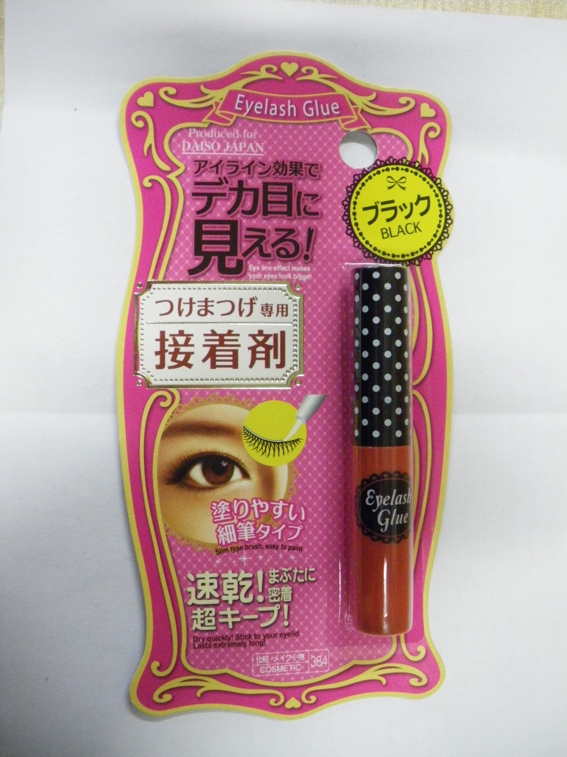
Eyelash glue- Cosmetic 909 | Purchased on 2 February 2015 at Daiso, Queen Victoria - Melbourne | <LOQ | Information on pack is in Japanese and English.  Ingredients listed:  Acrylate co-polymer, water, ethanol, d-sorbitol, methyl paraben. | 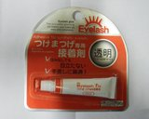
Eyelash glue - cosmetic - make accessories - 317 | Purchased on 2 February 2015 at Daiso, Queen Victoria - Melbourne | <LOQ | Information on pack is in Japanese and English.  Ingredients listed:  Acrylic resin, water. | 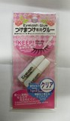
Eyelash glue - cosmetic - 900 | Purchased on 2 February 2015 at Daiso, Queen Victoria - Melbourne | <LOQ | Information on pack is in Japanese and English.  Ingredients listed:  2-ethylhexyl acrylate, water, iron oxide, methyl methacrylate, ethyl acrylate, methylacrylate-acid. | 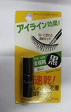
Eyelash glue - makeup s - makeup accessory 909 | Purchased on 2 February 2015 at Daiso, Queen Victoria - Melbourne | <LOQ | Information on pack is in Japanese and English.  Ingredients listed:  Aluminium polyethylene. | 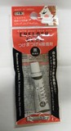
Eyelash glue - cosmetic 899 | Purchased on 2 February 2015 at Daiso, Queen Victoria - Melbourne | <LOQ | Information on pack is in Japanese and English.  Ingredients listed:  Ethanol, water, acrylate co-polymer, d-sorbitol, methyl paraben. | 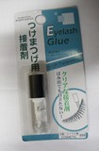
The Beauty Case - False eyelashes- adhesive 0.7ml - BC361 E, BC361 C, BC361 I | Purchased on 5 March 2015 at Price Attack - Canberra Centre | <LOQ | Information on pack is in English.  Ingredients listed:  Acrylate/ethylhexyl, acrylate copolymer, aqua. | 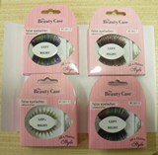
Eyelash glue - MAKE UP - Others 55 | Purchased on 28 January at Daiso - Myer Centre - Brisbane | <LOQ | Information on pack is in Japanese and English.  Ingredients listed:  Natural latex. | 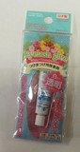
Eylure - Katy Perry Lashes - Lovely Lolita - false eyelash kit | Purchased on 5 March 2015 at Big W - Canberra Centre | <LOQ | Information on pack is in English.  Ingredients listed:  Rubber latex, aqua, hydroxypropyl, methylcellulose, phenoxyethanol, C9-11, alcohols, sodium salicylate, methylparaben, disodium edta, butylparaben, ethylparaben, isobutylparaben, propylparaben. | 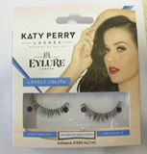
1000 Hour Hypo - allergenic Eyelash Adhesive | Purchased on 5 March 2015 at Priceline - Canberra Centre | <LOQ | Information on pack is in English.  Ingredients listed:  Aqua, co-polymer-acrylsaureester, ethylparaben, methylparaben. | 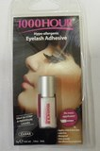
Ardell LashGrip for Strip Lashes | Purchased on 5 March 2015 at Priceline - Canberra Centre | 0.234 mg/kg formaldehyde (mean of 233, 236 mg/kg) | Information on pack is in English.  Ingredients listed:  Water, rubber latex, cellulose gum, sodium dodecylbezenesulfonate, ammonium hydroxide, fragrance, coumarin, geraniol, limonene, linalool, formaldehyde. | 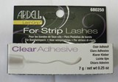
Ardell LashTite for Individual Lashes | Purchased on 5 March 2015 at Priceline - Canberra Centre | <LOQ | Information on pack is in English.  Ingredients listed:  Methoxyisopropyl acetate, nitrocellulose, alcohol denat. | 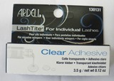
Glameyes Manicare | Purchased on 5 March 2015 at Priceline - Canberra Centre | <LOQ | Information on pack is in English.  Ingredients listed:  Water, styrene/acrylates/ammonium methacrylate copolymer, ethylparaben, methylparaben. | 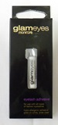
Revlon Precision Dark Lash Adhesive | Purchased on 5 March 2015 at Priceline - Canberra Centre | <LOQ | Information on pack is in English.  Ingredients listed:  2-ethylhexyl acrylate, water, methyl methacrylate, isobutyl acrylate, methacrylic acid, butylene glycol, oleth-10, polysorbate 60, phenoxyethanol, carbon black (CI 77266). | 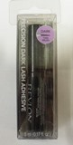

National Industrial Chemicals Notification and Assessment Scheme, Priority Existing Chemical Assessment Report No. 28, National Industrial Chemicals Notification and Assessment Scheme November 2006, viewed 14 August 2015, www.nicnas.gov.au/Publications/CAR/PEC/PEC28/PEC_28_Full_Report_PDF.pdf
Bainbridge, Amy, 4 Dec 2014 , Eyelash extensions causing serious injuries such as chemical burns and infections, ABC News, December 2014, viewed 14 August 2015, www.abc.net.au/news/2014-12-04/eyelash-extensions-optometrists-chemical-burns-infections/5939908
Personal Care Council, September 28, 2011, Cosmetic Ingredient Review Concludes Formaldehyde/Methylene Glycol Unsafe As Currently Used In Hair Straighteners, Personal Care Council, September 2011, viewed on 14 August 2015, www.personalcarecouncil.org/newsroom/20110928
European Commission, 2007, Formaldehyde and paraformaldehyde (*), European Commission, 2007, viewed on 14 August 2015, ec.europa.eu/consumers/cosmetics/cosing/index.cfm?fuseaction=search.details&id=28127&back=4
European Commission, 1982, Formaldehyde , European Commission, 1982, viewed on 14 August 2015, ec.europa.eu/consumers/cosmetics/cosing/index.cfm?fuseaction=search.details&id=28255&back=6

