ACCC analytical survey of carcinogenic aromatic amines in dyed textile articles in direct and prolonged contact with the skin

Final report

August 2015

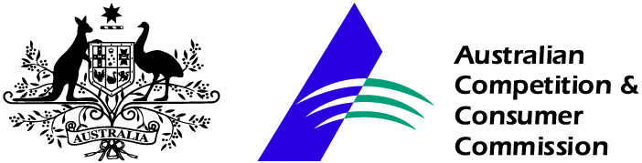

Contents

1. Background 3
2. Potential Hazards 4
3. Regulations and Standards 4
4. Survey aim and methodology 6
5. Results 7
6. Conclusion 7
Attachment 1 – Survey results 9
Men’s clothing 9
Women’s clothing 16
Children’s clothing 22
Manchester 28

This report describes the findings of an ACCC survey of hazardous aromatic amines in textile articles in direct and prolonged contact with the skin.
The report reflects the findings for the specific samples at the time of the survey only. The results should not be taken to be indicative for all products of the same kind either before, during or after the survey period.
When a survey result suggests a product may be unsafe or non-compliant the ACCC will contact the supplier and work with them to investigate the issue and remove the product from the marketplace where adverse results are confirmed.
Importantly, while adverse survey results may result in products being corrected quickly, there is also no assurance that favourable survey results will mean a product continues to be safe or compliant in the future.

1. Background

The Australian Competition and Consumer Commission (ACCC) plays an important role in consumer product safety. The ACCC administers national product safety regulations under the Competition and Consumer Act 2010 (CCA) and monitors the safety of consumer products. This includes educating suppliers and consumers about regulations, emerging issues, and the safe use of products to minimise the risk of injuries.

Azo dyes are synthetic dyes that may be used to colour consumer goods such as clothing, leather articles and possibly paper articles. They are also used in some hair dyes and printer inks. Although there are a large number of azo dyes, a small proportion of the dyes are hazardous because they may reduce to carcinogenic aromatic amines, including benzidine. Generally accepted public health policy suggests that exposure to carcinogens should be minimised or avoided whenever possible. The National Industrial Chemicals Notification and Assessment Scheme (NICNAS) has assessed the human health and environmental impacts of benzidine-based dyes as part of their Inventory Multi-tiered Assessment and Prioritisation (IMAP) framework. NICNAS recommended that the ACCC “… consider mechanisms to restrict the supply of textiles and leather articles [containing these chemicals] which may come into direct and prolonged contact with human skin…”.

In 2013 the ACCC conducted a survey of aromatic amines in 199 clothing, bedding and leather articles. Overall, carcinogenic aromatic amines were detected at above the EU limit of 30 mg/kg (or 30 parts per million (ppm)) in approximately 3 per cent of the tested articles. During 2013 and 2014, further testing of 107 similar articles was conducted. In 2013-14, thirty eight product lines (over 208 000 articles) were voluntarily recalled by suppliers, due to detections of aromatic amines above the 30 mg/kg limit. Detections of aromatic amines were traced to the substitution of dyes with hazardous azo dyes in the supply chains. Many suppliers undertook to improve their quality assurance and quality control actions to reduce the likelihood of future detections of carcinogenic aromatic amines in their products. Suppliers stated that they would:
- increase the frequency and breadth of testing of raw materials and finished products
- require manufacturers and raw material suppliers to demonstrate that their products were compliant with internationally agreed standards by provision of testing evidence
- ensure that supply chain participants made or were aware of agreements to provide materials or products that were compliant with internationally agreed standards – many adopted a ‘zero tolerance’ policy on use of azo dyes.

This survey of textile products in the Australian market was conducted to determine whether there had been reduction in the occurrence of carcinogenic aromatic amines (from hazardous azo dyes) in textiles since the 2013 survey.
2. Potential Hazards

The critical concern for azo dyes relates to the potential carcinogenic effects following dermal exposure in adults and children or the mouthing of products containing particular dyes. Some azo dyes reduce to form aromatic amines, including benzidine, a known carcinogen. Dermal exposure to benzidine-based dyes could occur though prolonged and direct contact with dyed textiles and leather articles. The release of carcinogenic aromatic amines is exacerbated by body heat, sweat and saliva.

In 1999 the 7th European Scientific Committee on Toxicity, Ecotoxicity and Environment meeting assessed the risk of cancer caused by textiles and leather goods coloured with certain azo dyes concluded that, while consumer exposure is likely to be ”very low“, the associated cancer risks give cause for concern.

3. Regulations and Standards
Internationally, use of benzidine-based azo dyes in textiles is expected to be gradually phased out, possibly due to the restrictions now being placed on these substances in major markets such as the EU and USA. This may lead to a decline in the presence of aromatic amines in consumer products available to Australian consumers.

Australia
Currently the only restrictions on the introduction or use of azo dyes or aromatic amines in Australia are as a result of national scheduling arrangements and the normal restrictions on introduction of industrial chemicals by the NICNAS. However, the ACCC is currently considering the introduction of additional arrangements to reduce the presence of carcinogenic aromatic amines in consumer goods.

The current Poisons Standard includes several benzidine-based dyes and benzidine-congener (3,3’-disubstituted) azo dyes in Schedule 7 (‘Dangerous poison’) . Substances included in Schedule 7 have a high potential for causing harm at low exposure and require special precautions during their manufacturing, handling or use. Schedule 7 poisons are only available to specialised or authorised users and there are special restrictions regarding their availability, possessions, storage or use.

On 21 October 2014, the ACCC published ‘acceptable limits’ of 30 mg/kg for aromatic amines in textile and leather articles on the Products Safety Australia website. The limit and aromatic amines align with the current restrictions in the European Union. The Australian ‘limit’ does not have a legislative basis and is provided for the information of suppliers who may be supplying products that contain aromatic amines.

International Regulations

European Union
In the EU, 22 aromatic amines derived from certain azo dyes are restricted in articles that come into direct and prolonged contact with skin or the mouth during normal use including clothing, bedding, towels, hairpieces, wigs, hats, nappies, sanitary items, sleeping bags, footwear, gloves, wristwatch straps, purses, wallets, briefcases, chair covers, textile or leather toys, yarn and fabric. The maximum concentration of each of the aromatic amines (listed in Table 1) is 30 mg/kg.

Table 1
Aromatic amines restricted in articles in direct and prolonged contact with the skin or mouth
(from Point 43 of Appendix 8 of Annex XVII to Regulation (EC) No. 1907/2006 of the European Parliament)

Aromatic amine | Synonyms | CAS number
biphenyl-4-ylamine | 4-aminobiphenyl  xenylamine | 92-67-1
benzidine |  | 92-87-5
4-chloro-o-toluidine |  | 95-69-2
2-naphthylamine |  | 91-59-8
o-aminoazotoluene | 4-amino-2’,3-dimethylazobenzene  4-o-tolylazo-o-toluidine | 97-56-3
5-nitro-o-toluidine |  | 99-55-8
4-chloroaniline |  | 106-47-8
4-methoxy-m-phenylenediamine |  | 615-05-4
4,4'-methylenedianiline | 4,4’-diaminodiphenylmethane | 101-77-9
3,3’-dichlorobenzidine | 3,3’-dichlorobiphenyl-4,4’-ylenediamine | 91-94-1
3,3’-dimethoxybenzidine | o-dianisidine | 119-90-4
3,3’-dimethylbenzidine | 4,4’-bi-o-toluidine | 119-93-7
4,4’-methylenedi-o-toluidine |  | 838-88-0
6-methoxy-m-toluidine | p-cresidine | 120-71-8
4,4’-methylene-bis-(2-chloro-aniline) | 2,2’-dichloro-4,4’-methylene-dianiline | 101-14-4
4,4’-oxydianiline |  | 101-80-4
4,4’-thiodianiline |  | 139-65-1
o-toluidine | 2-aminotoluene | 95-53-4
4-methyl-m-phenylenediamine |  | 95-80-7
2,4,5-trimethylaniline |  | 137-17-7
o-anisidine | 2-methoxyaniline | 90-04-0
4-amino azobenzene |  | 60-09-3

United States
In the US dyes based on benzidine and benzidine congeners d are covered by a significant new use rule (SNUR) under section 721.1660 of the Toxic Substances Control Act. The US Environmental Protection Agency (US EPA) must be notified at least 90 days before any manufacture, importation or use of these dyes for any significant new use. The US EPA evaluates the proposed manufacture, importation or use and may address risks to human health or the environment by limiting or prohibiting the use.

Canada
In 2006 azo dyes and aromatic amines group were identified by the Canadian government’s Chemicals Management Plan as a high priority for action. The Canadian government is currently publishing and receiving comment on final screening assessments for these chemicals. No further action is proposed at this time, given that the Canadian government does not expect that current levels of exposure are harmful to human health or the environment.

China
There are Chinese standards for leather and fur products and for textile products. Carcinogenic aromatic amines are banned in apparel, decoration textiles and household textiles in China. The limit for aromatic amines in leather and fur is 30 mg/kg.

Japan
Japan has adopted the EU 22 restricted amines and added a further 2 aromatic amines to the Japanese list: 2,6-xylidine (CAS 87-62-7) and 2,4-xylidine (CAS 95-68-1). On 8 April 2015 Japan’s Ministry of Health, Labour and Welfare amended Article 2 of the Act on Control of Household Products Containing Harmful Substances (Act 112 of 1973) 24 aromatic amines (in force from 1 April 2016).

New Zealand
There are no regulations restricting the presence of aromatic amines in clothing or textiles in New Zealand. Following the 2013 survey of aromatic amines on clothing, bedding and leather goods, New Zealand undertook recalls of the affected articles that were also supplied in New Zealand. Some products were also recalled by the Consumer Affairs Department in New Zealand following the recalls that resulted from the current survey.

4. Survey aim and methodology

4.1 Survey aim

This survey was designed as a follow-up to a similar survey in 2013.

In 2013, 199 articles from mainstream ‘bricks-and-mortar’ stores or online suppliers were tested for presence of aromatic amines. In that survey there were detections of aromatic amines above the acceptable concentration of 30 mg/kg in four styles of darkly coloured jeans and one pillowslip. About 97 per cent of articles tested were below the acceptable limit of 30 mg/kg aromatic amines. In Australia, this survey resulted in 13 voluntary recalls of 38 product lines and close to 208 500 articles. Recalls were also conducted in other countries where the affected products were also being supplied.

4.2 Survey and testing methodology

Clothing and bedding articles were purchased from traditional ‘bricks-and-mortar’ and online suppliers to reflect the shopping habits of Australian consumers. Articles were purchased in Melbourne, Sydney, Perth and Darwin. Only articles that are worn or used in direct and prolonged contact with the skin and strongly or intensively dyed were selected. Products purchased included jeans, leggings, pants, shorts, t-shirts, shirts/tops, sportswear, underwear, socks, sleepwear and pillowcases.

Articles were sent to Intertek Testing Services Hong Kong Limited for testing according to the following standards:
- EN 14362-1:2012 Textiles – methods for determination of certain aromatic amines derived from azo colorants – Part 1. Detection of the use of certain azo colorants accessible with and without extracting fibres.
- EN 14362-3:2012 Textiles – methods for determination of certain aromatic amines derived from azo colorants – Part 3. Detection of the use of certain azo colorants, which may release 4-aminoazobenzene.

All articles were new and unwashed. Articles were tested according to EN 14362-1:2012. If aniline or 1,4-phenylenediamine were detected, the articles were also tested according to EN 14362-3:2012 for the presence of 4-aminoazobenzene. Testing was requested for all components of the articles that were in direct and prolonged contact with the skin during normal wear or use. For clothing this included the main fabric of articles and various waistbands, linings and inner pocket pieces.

Results were provided to the ACCC in standard reports, which included photographs of the tested articles and results for all parts of the articles that were tested.

When initial testing gave results for aromatic amines close to the 30 mg/kg limit, the laboratory was instructed to wash the article by a standard method (AS 2001.5.4-2005 Methods for test of textiles – dimensional change – domestic washing and drying procedures for textile testing) and re-test. The results for pre-and post- washing tests are presented in this report.

5. Results
The complete list of products surveyed and the testing results for this survey are in Attachment 1. Results are arranged in separate sections for men’s clothing, women’s clothing, children’s clothing and manchester (bedding). Articles with detections of aromatic amines are listed first in the relevant section. Country of origin of articles is included where this is known. The supplier of the product is included in the results table, although some products may also be available from suppliers other than the one listed.
Three of the 28 articles of men’s clothing tested had detections of aromatic amines at concentrations above 30 mg/kg – two pairs of jeans and one colour version from a set of assorted men’s business socks. One pair of women’s jeans from 27 articles of women’s clothing had detections of aromatic amines above 30 mg/kg. None of the 24 articles of children’s clothing had detections of aromatic amines above the 30 mg/kg limit. There were no detections of any aromatic amines in any of the 19 bedding articles tested.

6. Conclusion
Aromatic amines above 30 mg/kg were detected in 4/102 articles tested (approximately 4 per cent). The frequency of detection of aromatic amines above 30 mg/kg in this survey was similar to the results of the 2013 survey.

The products with greater than 30 mg/kg aromatic amines in this survey were voluntarily recalled from the Australian market in July 2015.

At the time of writing, the Australian government was considering whether to introduce regulations that restrict the presence or concentration of carcinogenic aromatic amines in textile and leather products worn or used in direct and prolonged contact with the skin or mouth.

Attachment 1 – Survey results

Men’s clothing

Product | Supplier | Aromatic amine detections | Photograph
Men’s jeans  Staple Superior Goods & Apparel Mody Chinos, SKU ST892AA24NQL (packaging notes style STSS1406009), cotton rich twill, 97% cotton, 3% elastane, classic slim fit, colour sapphire, size 36.  Made in China. | The Iconic | 68 mg/kg 3,3’ dimethoxybenzidine in the main fabric  130 mg/kg p-aminoazobenzene in the pocket lining | 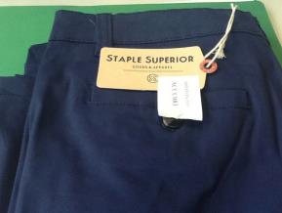
Men’s socks  Underworks 5 pack cotton rich, men’s business socks, various colours.  Made in China. | Best & Less | 78 mg/kg p-aminoazobenzene in knitted sock cuff lining (only one colour affected) | 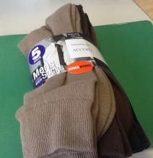
Men’s jeans  Bullshead Classic Fit Jeans 3013HS-S, style 131136004, black, size 84.  Made in China. | Harris Scarfe | Before washing – 34 mg/kg benzidine in the pocket lining  After washing – 22 mg/kg benzidine in the pocket lining | 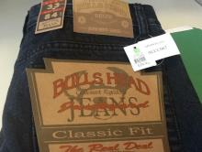
Men’s jeans  Swagger Jean (product code 524090-07), washed charcoal colour, size 34.  Made in Bangladesh. | Factorie | 7 mg/kg 3,3’-dimethoxybenzidine in the main fabric  11 mg/kg 3,3’-dimethoxybenzidine in the pocket lining | 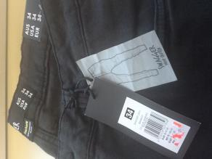
Men’s jeans  Breakers Straight jeans, black, size 97.  Made in Bangladesh. | Best & Less | 7 mg/kg p-chloroaniline in the main fabric | 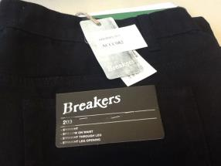
Men’s jeans  Skinny Straight Leg / Spitfire Jean, low rise, straight leg jean, Cotton On's most popular men's jeans, product code 390548, 98% cotton, 2% elastane blend, raw indigo rinse.  Made in China. | Cotton On | nil | 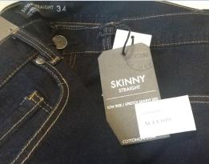
Men’s top  Ninety one by Cotton On, muscle tank, Tibetan red, size M.  Made in Bangladesh. | Cotton On | nil | 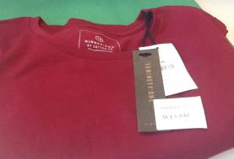
Men’s shorts  Manta Ray men’s shorts, black, size M.  Made in Bangladesh. | Best & Less | nil | 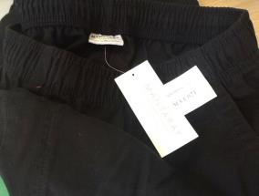
Men’s jeans  CR Denim, slim washed jean, code 60172456, denim, size 36R. | Country Road | nil | 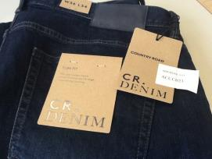
Men’s shirt  Kenji Flashback Paisley Shirt (product code 263096380)(style number KW15307), 100% cotton, burgundy, size L.  Made in China. | Myer Online | nil | 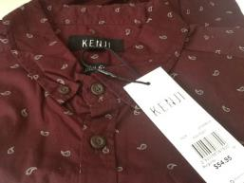
Men’s sportswear  Adidas Sonar TSH t-shirt, Climalite, 0278279880, black and white, size L. | Myer | nil | 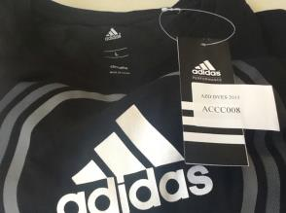
Men’s sportswear  T30 compression long pant, polyester/elastane, black, size XL.  Made in China. | Target | nil | 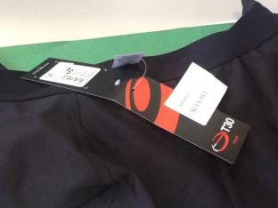
Men’s shorts  Essential Men's contemporary elastic short, midnight, 54986473, size M.  Made in Bangladesh. | Target | nil | 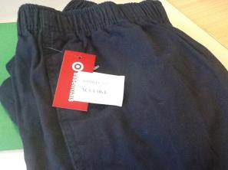
Men’s jeans  Beatnik Jean, OD navy (product code 524100-04), stretch, skinny fit, mid-rise jean, tapers at leg, size 34. | Factorie | nil | 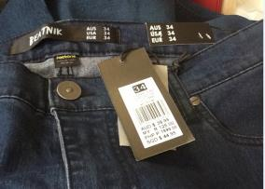
Men’s workwear  Jackeroo work pant, navy blue, size 87.  Made in China. | KMart | nil | 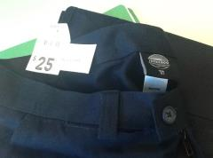
Men’s jeans  Straight Leg Jeans in Mineral Wash, mineral wash (the base colour has undergone treatment giving the blue black denim a washed out appearance) size 34.  Made in China. | Jeans West | nil | 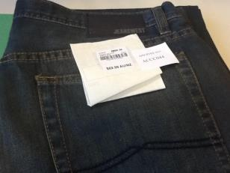
Men’s jeans  Quicksilver, relaxed fit, double up blue, men's jeans, size 34.  Made in Guatemala. | Trade Secret | nil | 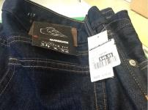
Men’s jeans  Military Slim Fit Jean, indigo.  Made in China. | yd. | nil | 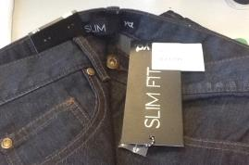
Men’s jeans  Fiennes Casual Pant, style 14CBOC11, 98% cotton, 2% elastane, colour cigar (brown).  Made in China. | yd. | nil | 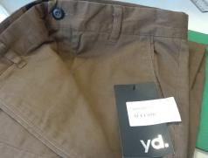
Men’s top  Roller Tee, colour charcoal.  Made in China. | yd. | nil | 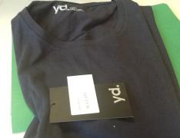
Men’s jeans  210 Ink Super Skinny Jean, style line 036479, 98% cotton, 2% elastane, colour ink, size 34.  Made in China. | Just Jeans | nil | 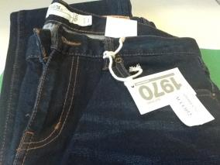
Men’s jeans  Skinny Chino, style line 181915C, low rise, 99% cotton, 1% elastane, colour Federal blue, size 36.  Made in China. | Just Jeans | nil | 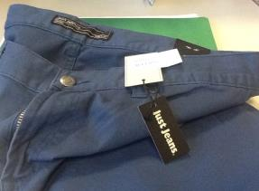
Men’s underwear  Mitch Dowd Soft Wash, navy blue, size XL.  Made in China. | Harris Scarfe | nil | 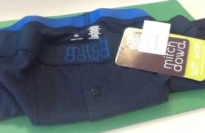
Men’s workwear  Short sleeve work shirt, navy blue, size L.  Made in China. | Lowes | nil | 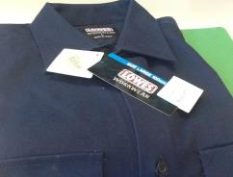
Men’s jeans  Street Jeans, blue denim, size 34.  Made in China. | Lowes | nil | 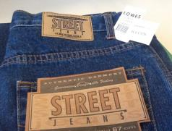
Men’s shirt  Party Time Purple Shirt, product code 448-13-232260, purple, size L.  Made in Bangladesh. | Lowes | nil | 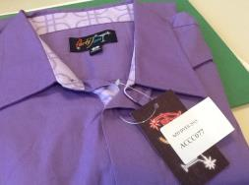
Men’s underwear  Lowes 4 Pack Hipster Briefs, one size S and one size M.  Made in China. | Lowes | nil | 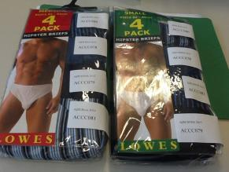
Men’s pants  Breakers, straight leg, navy blue, size 32.  Made in China. | Best & Less | nil | 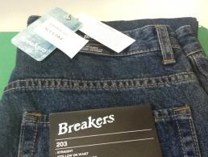

Women’s clothing
Product | Supplier | Aromatic amine detections | Photograph
Women’s jeans  Elly Skinny Jean, skinny leg fit, 5 pocket jean, product code 238485-06, 98% cotton, 2% elastane, dark blue.  Made in China. | Cotton On | Before washing 34 mg/kg p-aminoazobenzene in the pocket lining  After washing 110 mg/kg p-aminoazobenzene in the pocket lining  6 mg/kg p-aminoazobenzene in the main fabric | 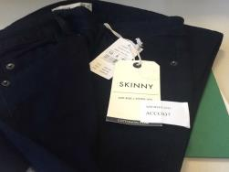
Women’s jeans  Comfort regular length boot leg jeans, 1025367, indigo, size 16.  Made in China. | Rockmans | 18 mg/kg 3,3’-dimethoxybenzidine in the main fabric  15 mg/kg 3,3’-dimethoxybenzidine in the waistband lining | 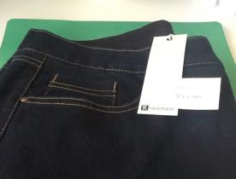
Women’s top  Harlow Crop, long sleeve, black, size XL.  Made in China. | Factorie | 6 mg/kg p-chloroaniline in the main fabric | 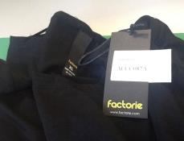
Women’s jeans  Lee Hi Rider Jeans, product number LE634AA86SFH-613776, 98% cotton, 2% elastane, skinny fit, colour denim.  Made in Thailand. | The Iconic | nil | 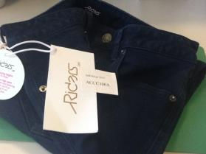
Women’s jeans  The Skinny High Rise 7/8 Jean, product code 241200, 75% cotton, 21% polyester, 3% viscose, 1% elastane, varsity blue colour.  Made in China. | Cotton On | nil | 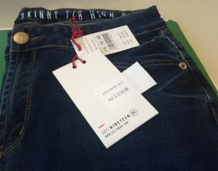
Women’s leggings  Emerson Crop Leggings, black, size 14.  Made in Bangladesh. | Big W | nil | 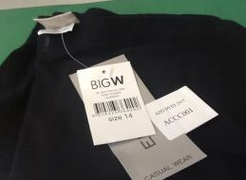
Women’s pants  Emerson Woman Jeggings, burgundy, size 14.  Made in China. | Big W | nil | 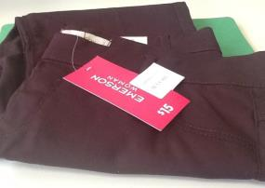
Women’s sleepwear  Romantic Hamptons Sleep Top - black, cotton/viscose, black, size 16.  Made in China. | Target | nil | 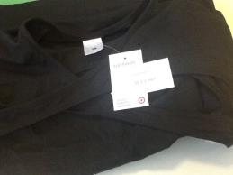
Women’s jeans  Baxter Jean, product code 519720-58, 98% cotton, 2% elastane, colour blue steel, size 10.  Made in Bangladesh | Factorie | nil | 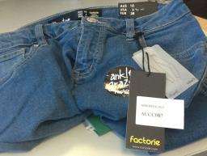
Women’s pants  Bengaline pants, 9443WWPNT, stretch poly blend (viscose/polyester/elastane), stretch waist, mid-rise, 3/4 leg, ink colour, size 12.  Made in China. | Rivers | nil | 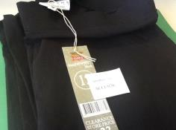
Women’s pants  Harem pants 1362WWPNT, rayon, mid-rise, zip drag up harem pants, black, size 16.  Made in China. | Rivers | nil | 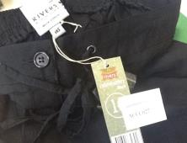
Women’s jeans  Breakers Ladies Chloe Boyfriend jean, 318221, dark blue, size 14.  Made in China. | Best & Less | nil | 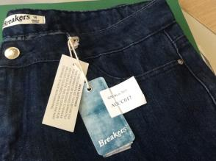
Women’s jeans  Patty Skinny jean, black, size 34.  Made in Bangladesh. | Best & Less | nil | 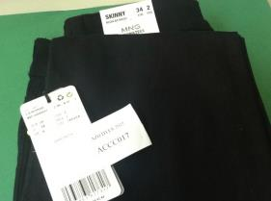
Women’s leggings  Women's Leggings, black, 198025 size 16.  Made in China. | Best & Less | nil | 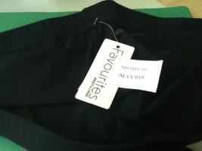
Women’s sportswear  ed.it.ed Favourites tracksuit pants, black, size 16.  Made in China. | Best & Less | nil | 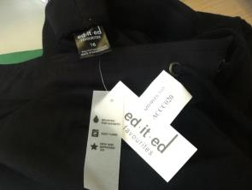
Women’s top  Women's textured t-shirt/top V-neck, 9470WKTOP, 65% polyester, 35% cotton, ruby red, size 12.  Made in China. | Rivers | nil | 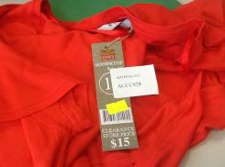
Women’s pants  Bootleg pants, black, size 12.  Made in China. | KMart | nil | 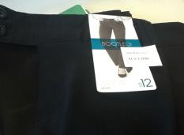
Women’s jeans  Breakers Slimming Jeans, 293583, black, 82% cotton, 17% polyester, 1% spandex, size 18.  Made in China. | Best & Less | nil | 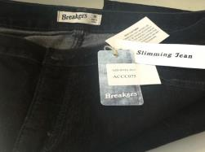
Women’s jeans  Guess Power Skinny Low Optic Wash 034OPTC Jeans SKU, 72% cotton, 20% polyester, 8% elastane, solid black wash, size 30.  Made in Mauritius. | The Iconic | nil | 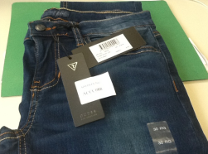
Women’s jeans  ‘Viv’ Skinny 7/8 Jeans, product code 72339, 76% cotton, 22% polyester, 2% elastane, super stretch denim, skinny 7/8 length, mid-rise, 5 pocket styling, 9.2oz denim, dark saturated indigo ink colour, size 12.  Made in China. | Jeans West | nil | 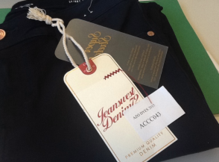
Women’s jeans  Rusty Women's low waist, relaxed fit jeans, black, size 12.  Made in China. | Trade Secret | nil | 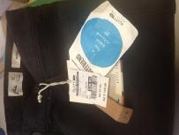
Women’s jeans  High Rise Slim Indigo Jean, style line 036777, 5-pocket design, 98% cotton, 2% elastane, colour indigo.  Made in China. | Just Jeans | nil | 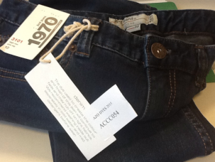
Women’s jeans  Lift N Shape Jean, style line 036722, mid-rise jean in stretch denim, 79% cotton, 19% polyester, 2% elastane, blue black colour, size 12.  Made in China. | Just Jeans | nil | 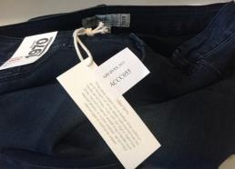
Women’s jeans  Urban Jeans Co. Stretch Classic Straight Jean, style 475153, mid-rise, 5 pocket design, stretch cotton/polyester/elastane, Ind-Rinse-Wash colour, size 16.  Made in China. | Harris Scarfe | nil | 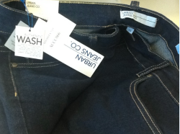
Women’s sportswear  Sfida Amelia Ladies Short, black/mid pink, size 14.  Made in China. | Harris Scarfe | nil | 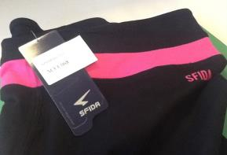
Women’s sportswear  Adidas Clima Essential 3 Stripe Tank - Berry, 84% polyester, 16% elastane, dark pink.  Made in The Philippines. | Harris Scarfe | nil | 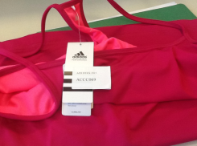
Women’s top  3/4 Plain V-Tee, 1025486, electric blue, size S.  Made in Bangladesh. | Rockmans | nil | 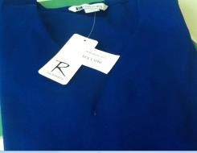

Children’s clothing
Product | Supplier | Aromatic amine detections | Photograph
Girl’s underwear  Girl’s 2 pack shortie briefs, cotton/elastane, navy blue, size 10-12.  Made in China. | Target | 9 mg/kg 4,4’-diaminodiphenylmethane in combined sample of main fabric, crotch lining and waistband | 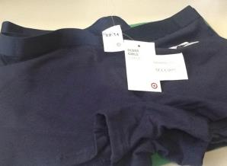
Boy’s underwear  Bonds Boy’s hipster fit trunks (style number 132733), green, size 14-16.  Made in China. | Big W | 5 mg/kg 4,4’diaminodiphenylmethane in combined sample of main fabric and waistband | 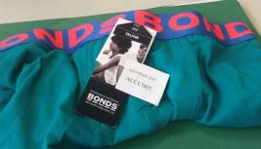
Girl’s sportswear  Rio 2 pack netball knickers shorts (style number 132739), maroon, size 12-14.  Made in China. | Big W | nil | 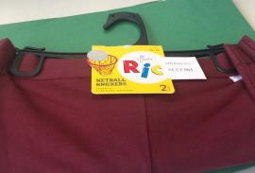
Boy’s shirt  Breakers Denim shirt, black, size 16.  Made in China. | Best & Less | nil | 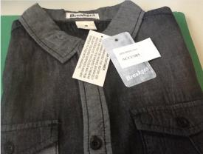
Boy’s top  Tilt, long sleeve boy’s top, black, size 10.  Made in Bangladesh. | Best & Less | nil | 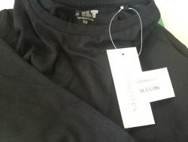
Boy’s underwear  Boys Bonds 2 pack briefs - cotton, blue and red, size 12-14.  Made in China. | Target | nil | 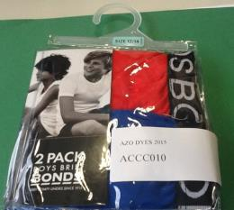
Girl’s jeans  Girls' Essentials mid wash denim jeans, cotton/polyester/elastane, dark blue denim, size 10.  Made in Bangladesh. | Target | nil | 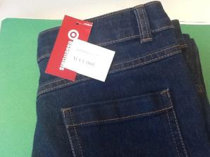
Girls' jeggings  Cotton/polyester/elastane, dark blue, size 10.  Made in Bangladesh. | Target | nil | 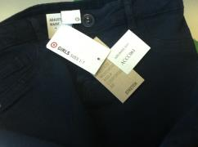
Boy’s pants  Boys' Jacob & Co Suit Pants - three pocket design, black, size 10.  Made in Vietnam. | Target | nil | 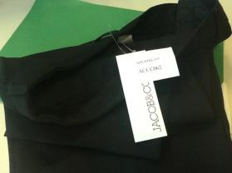
Boy’s jeans  Boys' World Industries Kat Jeans, 5 pocket design, cotton/elastane, black, size 10.  Made in China. | Target | nil | 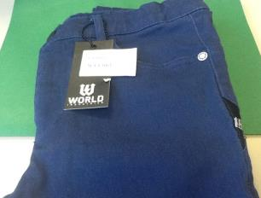
Girl’s shorts  Stretch, shorts, 1772GYSHO, black, size 10.  Made in China. | Rivers | nil | 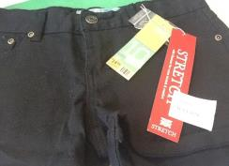
Girl’s jeans  Girls-youth, 5 pocket jeans, cotton/elastane, 1854GYJNS, dark denim.  Made in China. | Rivers | nil | 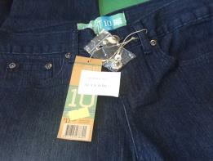
Girl’s jeans  Girls twill jeans, medium weight cotton with a touch of elastane, 1781GJNS, 5 pocket design, cotton/elastane, blue.  Made in China. | Rivers | nil | 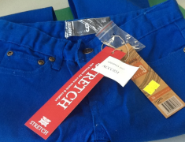
Boy’s shorts  Boy's woven slub shorts, 1752BYSHO, cotton, navy.  Made in China. | Rivers | nil | 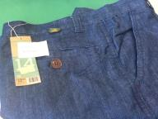
Boy’s shorts  Boys shorts, 1751BYSHO, red, size 14.  Made in China. | Rivers | nil | 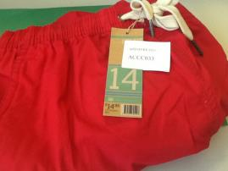
Boy’s jeans  Boys 5 pocket twill pants, black, size 12.  Made in China. | KMart | nil | 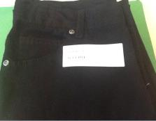
Girl’s top  Girls top, navy blue, size 7. | KMart | nil | 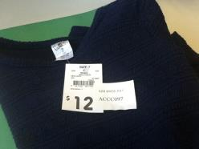
Child’s jeans  Soul & Glory Adjustable Waist Denim jeans, blue denim, size 7-8 years.  Made in Pakistan. | Trade Secret | nil | 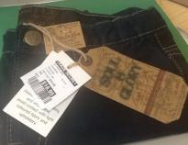
Child’s jeans  French Connection Jeans Trouser, indigo, size 12-13 years.  Made in Bangladesh. | Trade Secret | nil | 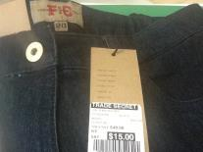
Girl’s jeans  Stretch Biker Jean, style line 160235, skinny fit, poly/cotton/elastane, colour black, size 12.  Made in China. | Just Jeans | nil | 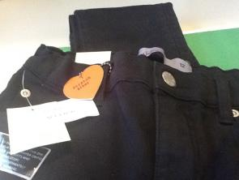
Boy’s school wear  Bearer and Ley Boys Blocker Short, bottle green, size 16.  Made in China. | Lowes | nil | 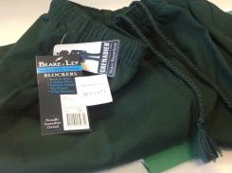
Girl’s schoolwear  Bottle Bootleg Pants, product code 792-03-10688, bottle green.  Made in Australia. | Lowes | nil | 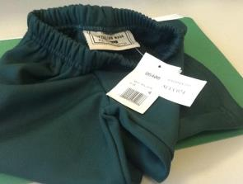
Boy’s shorts  DKNY Bermuda Shorts, style number 4818-410823, cotton twill, red, size 12M.  Made in India. | David Jones | nil | 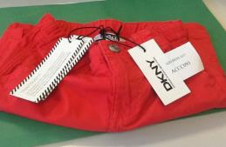
Girl’s jeans  Pavement Presley Jean, style 4541-407898, dark wash colour, size 12. | David Jones | nil | 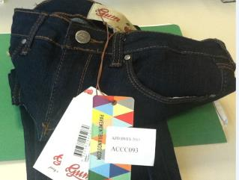

Manchester
Product | Supplier | Aromatic amine detections | Photograph
Manchester – pillowcases  Allura Linen Hotel Collection, 400 thread count, 100% cotton sateen finish, black.  Made in China. | Manchester Collection | nil | 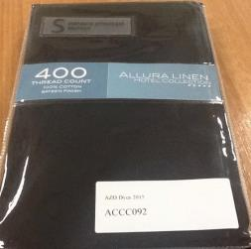
Manchester – pillowcases  Logan & Mason 100% cotton sateen, 400 thread count, standard pillowcase 48 x 74 cm, colour navy. | Manchester Warehouse Online | nil | 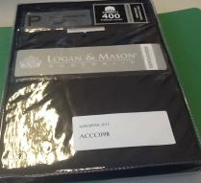
Manchester – pillowcases  Logan & Mason 100% cotton sateen, 400 thread count, standard pillowcase 48 x 74 cm, colour ruby. | Manchester Warehouse Online | nil | 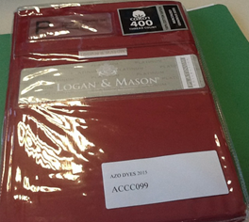
Manchester – pillowcases  Logan & Mason 50% combed breathable cotton, 50% polyester, 250 thread count, percale weave, pair of standard pillowcases, 48 X 73 cm, colour chocolate. | Manchester Warehouse Online | nil | 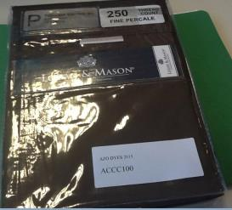
Manchester – pillowcases  House and Home ruffled U pillowcases, 250 thread count, polyester/cotton, black.  Made in China. | Big W | nil | 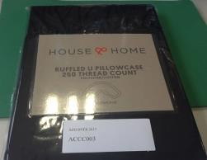
Manchester – pillowcases  Sheridan Classic Percale, 300 thread count European pillowcases (product code 112347100), cotton, red.  Made in China. | Myer Online | nil | 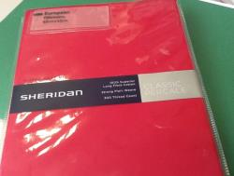
Manchester – pillowcases  Essentials pillowcase 2 pack (Reflection Collection) - tango red, item code 56020960, polyester/cotton, standard pillowcases, 48 x 73cm, 180 thread count, red.  Made in Bangladesh. | Target | nil | 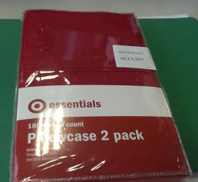
Manchester – pillowcases  Essentials pillowcase 2 pack (Reflection Collection) - polyester/cotton, standard pillowcases, 48 x 73cm, 250 thread count, navy blue.  Made in China. | Target | nil | 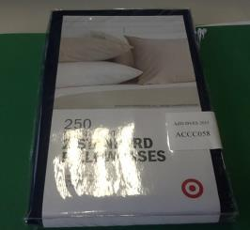
Manchester – pillowcases  Aspire standard pillowcase, plain dyed 250 thread count pillowcase polyester/cotton, standard, rouge (red).  Made in China. | PillowTalk Online | nil | 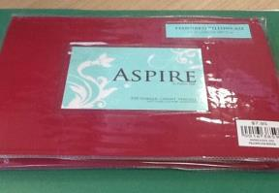
Manchester – pillowcases  Aspire standard pillowcase, plain dyed pillowcase polyester/cotton, standard, ocean (dark blue).  Made in China. | PillowTalk Online | nil | 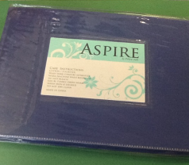
Manchester – pillowcases  Essentials Simplicity standard pillowcase, plain dyed pillowcase polyester/cotton, standard, black.  Made in China. | PillowTalk Online | nil | 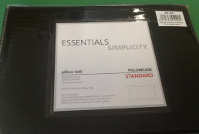
Manchester – pillowcases  Essentials Simplicity standard pillowcase, plain dyed pillowcase polyester/cotton, standard, purple.  Made in China. | PillowTalk Online | nil | 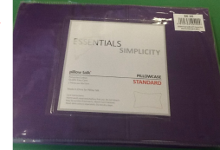
Manchester – pillowcases  Essentials Simplicity standard pillowcase, plain dyed pillowcase polyester/cotton, standard, red.  Made in China. | PillowTalk Online | nil | 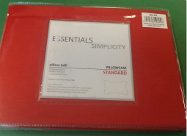
Manchester – pillowcases  Homemaker Standard Pillowcase (48 x 74 cm) SKU: P_40021263, polyester/cotton, 225 thread count, standard size, indigo.  Made in Bangladesh. | KMart | nil | 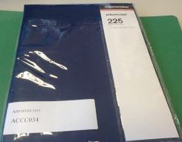
Manchester – pillowcases  Homemaker Body Pillowcase (48 x 74 cm), polyester/cotton, 180 thread count, body pillow case, 52 cm x 1.37m, colour plum (purple).  Made in China. | KMart | nil | 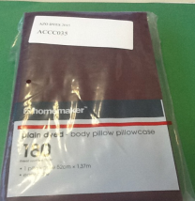
Manchester – pillowcases  Homemaker Standard Pillowcase (48 x 74 cm), SKU: P_40317670, polyester/cotton, 225 thread count, standard size, colour damson purple.  Made in Bangladesh. | KMart | nil | 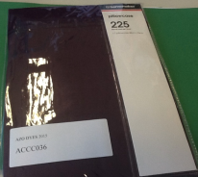
Manchester – pillowcases  Linen House, polyester/cotton percale, 250 thread count, standard U-Shaped pillowcase, black. | Harris Scarfe | nil | 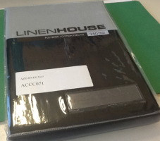
Manchester – pillowcases  Dekora Percale Bed Linen, 230 thread count, polyester cotton percale, 48 x 73cm, royal blue.  Made in Pakistan. | Lincraft | nil | 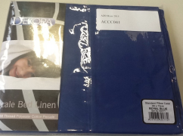
Manchester – pillowcases  Dekora Percale Bed Linen, 230 thread count, polyester cotton percale, 48 x 73cm, espresso.  Made in Pakistan. | Lincraft | nil | 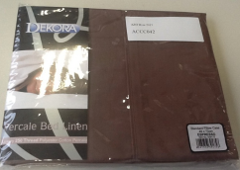

http://www.nicnas.gov.au/chemical-information/imap-assessments/imap-group-assessment-report?assessment_id=513
http://ec.europa.eu/health/scientific_committees/environmental_risks/opinions/sctee/sct_out27_en.htm
https://www.productsafety.gov.au/content/index.phtml/itemId/1009938/fromItemId/980990
http://ec.europa.eu/enterprise/sectors/chemicals/files/markrestr/annex_xvii_301206_en.pdf
http://www.chemicalsubstanceschimiques.gc.ca/fact-fait/glance-bref/amines-eng.php
Chinese Standard GB 20400-2006 Leather and fur – limit of harmful matter http://infostore.saiglobal.com/store/details.aspx?ProductID=814018
Chinese Standard GB 18401-2010 National general safety technical code for textile products http://infostore.saiglobal.com/store/Details.aspx?ProductID=1491451

