Kidde Fire Extinguisher Recall
Identification Guide
(For Australian Sold Units)

Model Numbers: FA5G, H5G, M5G, FC5, FS5, M5GM, FX5 II
Description: Extinguisher 2-3lb Mariner 5
Colour: White
Vertical Pull Pin
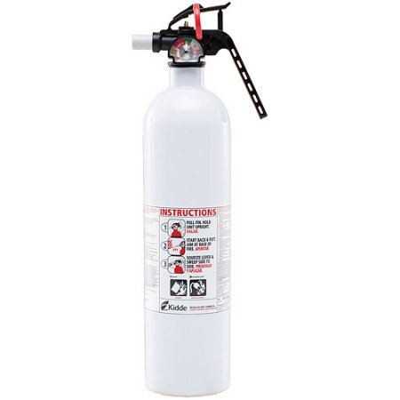
Model Number
Straight Handle

Similar model not included in recall
Horizontal Pull Pin
Curved Handle

